UV_BoreholeVolume_1_1 = ( V0 ) **(sloj 1)**

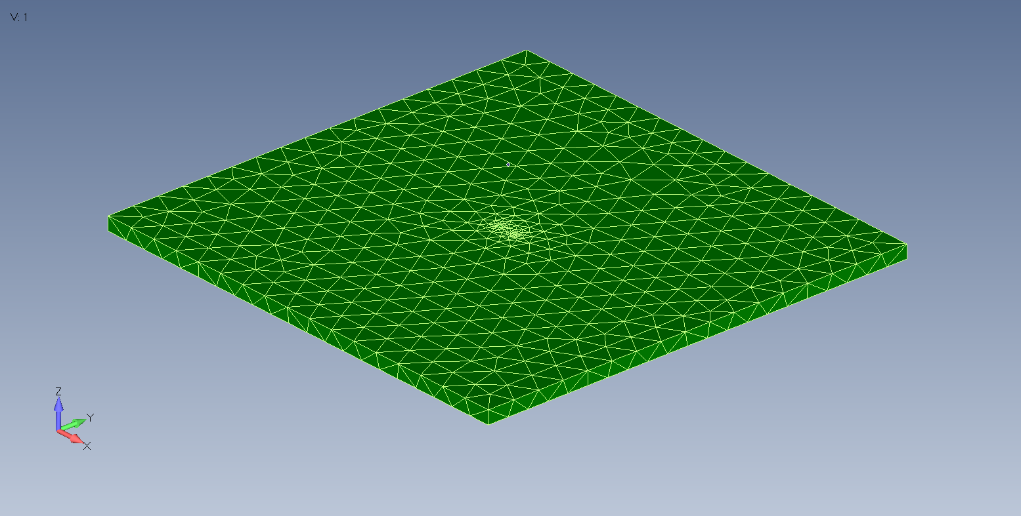

MV_BoreholeVolume_1_1 = ( S0, S1, S11, S2, S22, S3, S33, S38 ) **(povrsine sloja 1)**

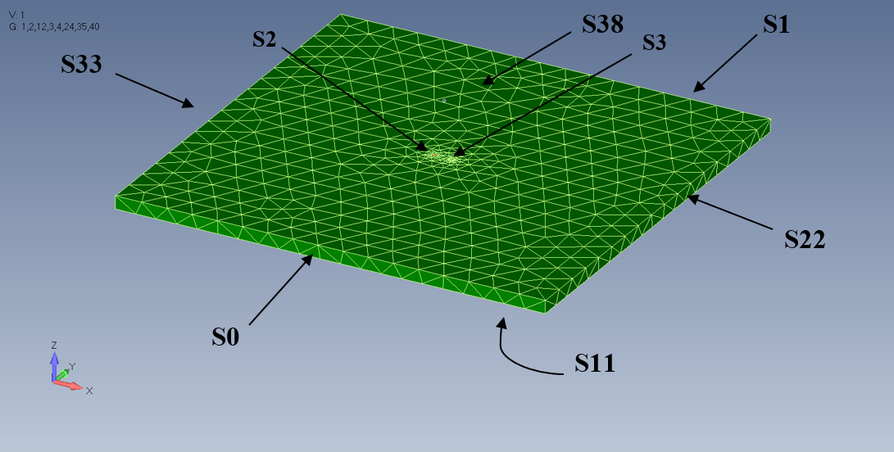

UV_BoreholeVolume_1_Volume_1_1 = ( V1 ) **(deo prvog stuba u sloju 1)**

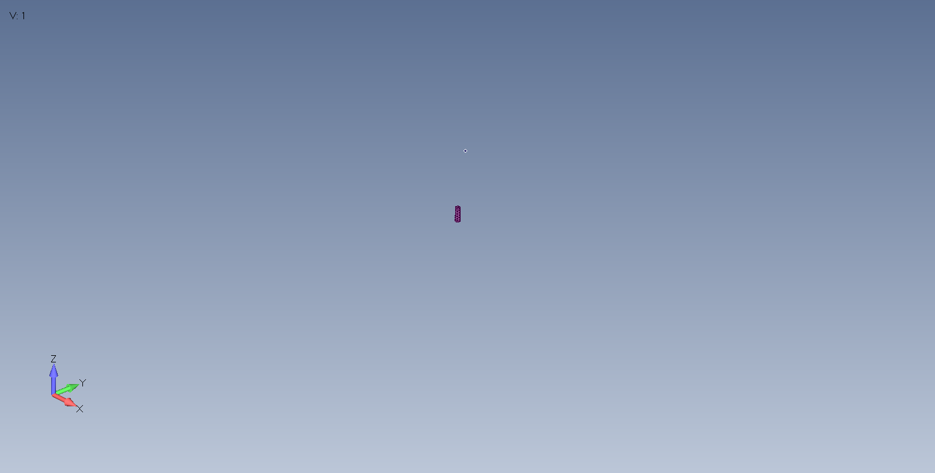

MV_BoreholeVolume_1_Volume_1_1 = ( S2, S4, S5 ) **(povrsine na delu prvog stuba u sloju 1)**

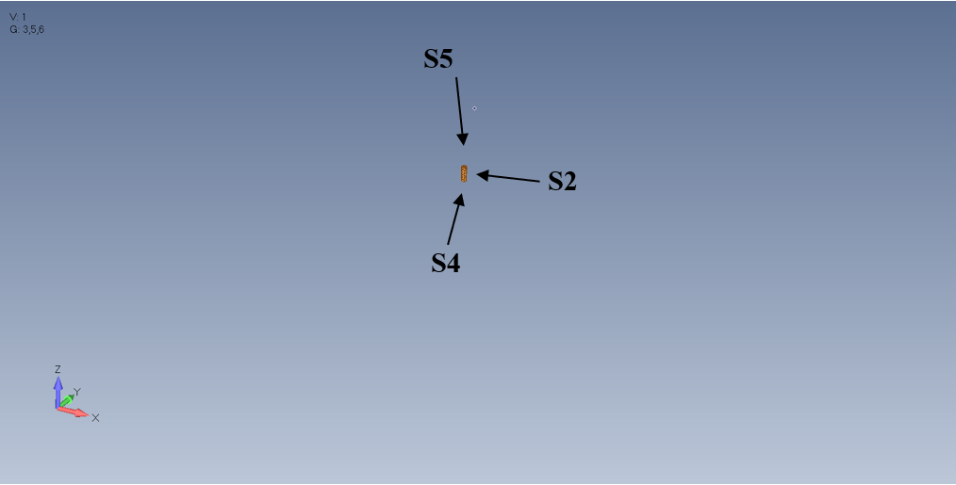

UV_BoreholeVolume_1_Volume_2_1 = ( V2 ) **(deo drugog stuba u sloju 1)**

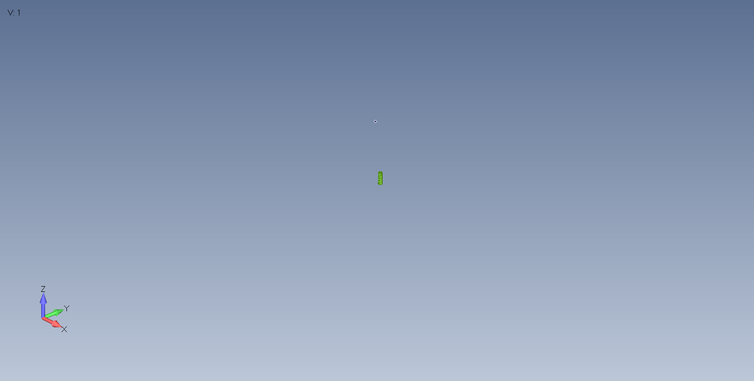

MV_BoreholeVolume_1_Volume_2_1 = ( S3, S6, S7 ) **(povrsine na delu drugog stuba u sloju 1)**

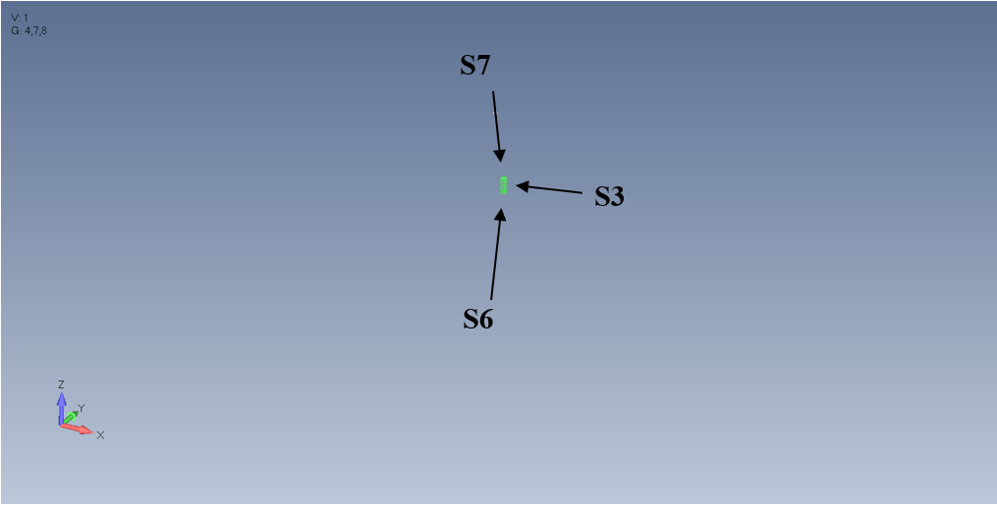

UV_BoreholeVolume_2_1 = ( V3 ) **(sloj 2)**

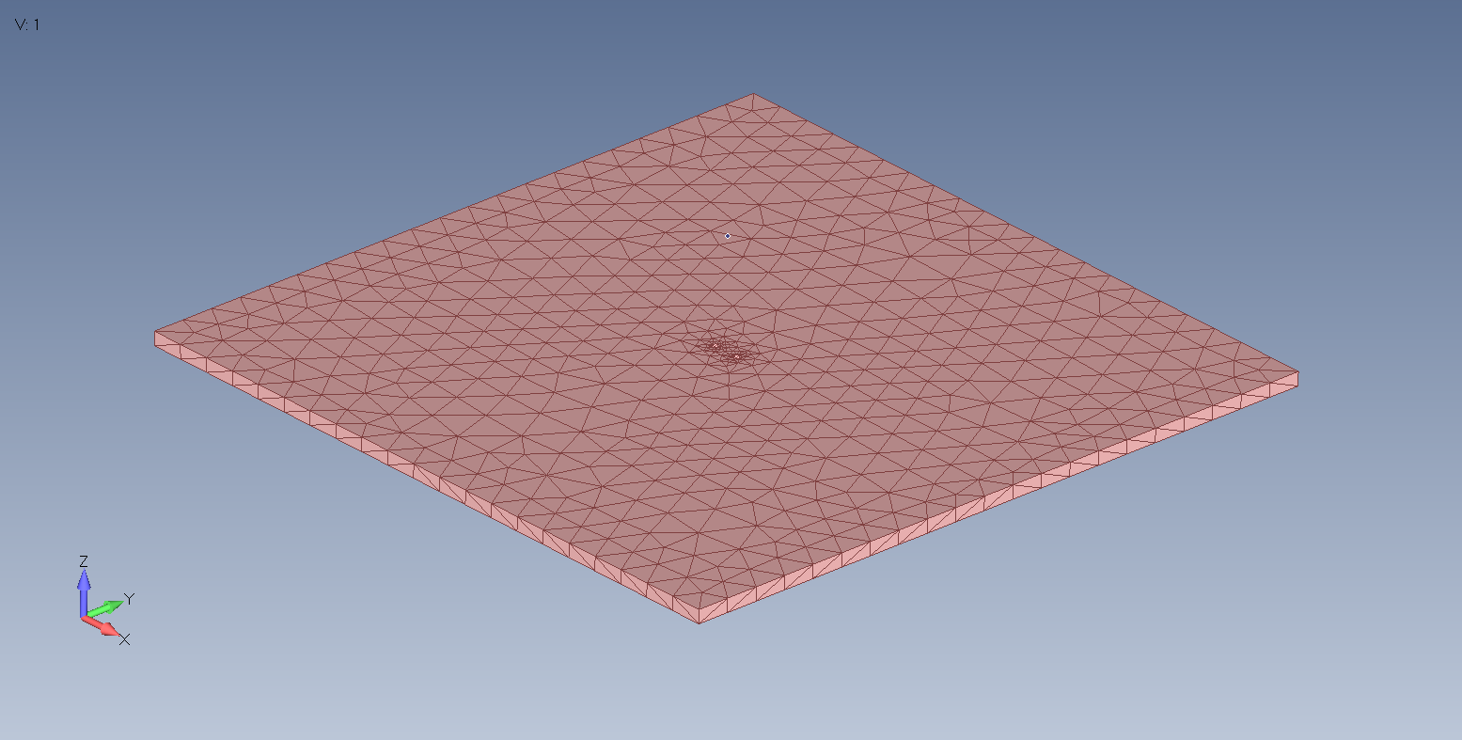

MV_BoreholeVolume_2_1 = ( S10, S11, S12, S13, S14, S15, S8, S9 ) **(povrsine sloja 2)**

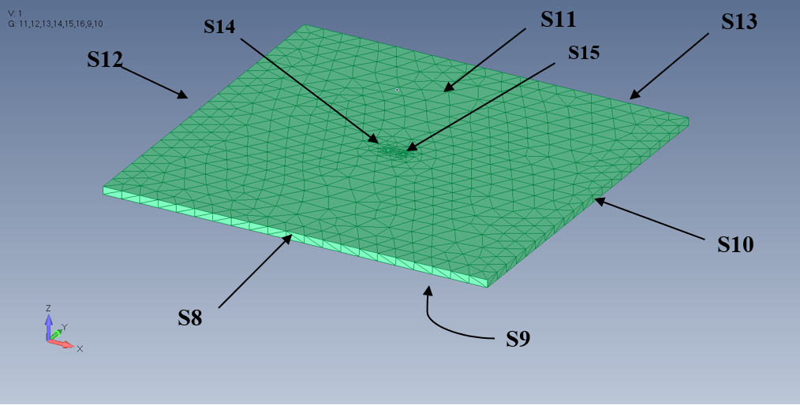

UV_BoreholeVolume_2_Volume_1_1 = ( V4 ) **(deo prvog stuba u sloju 2)**

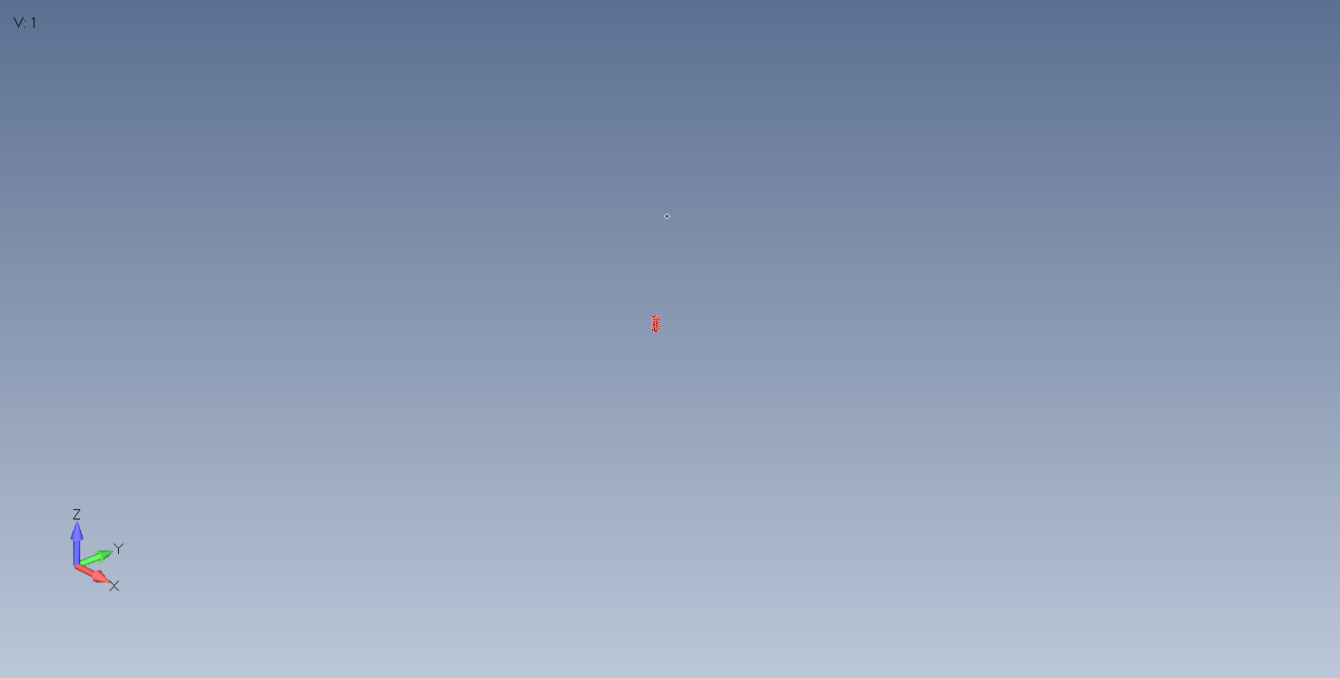

MV_BoreholeVolume_2_Volume_1_1 = ( S14, S16, S4 ) **(povrsine na delu prvog stuba u sloju 2)**

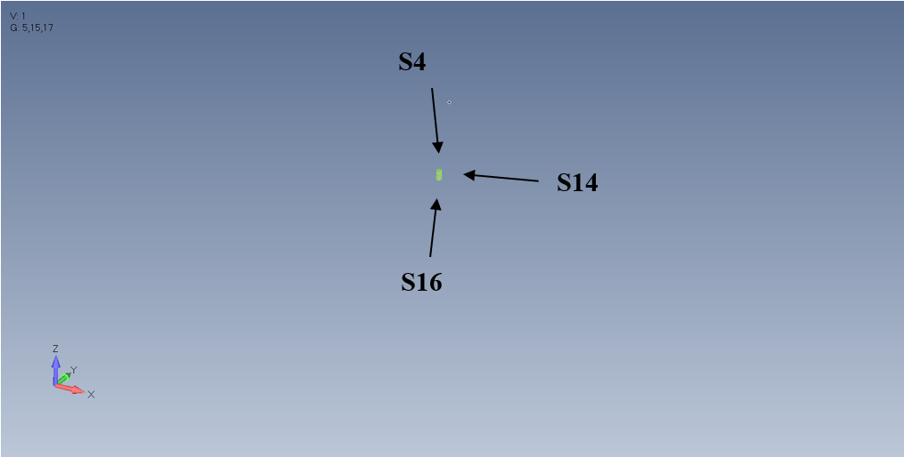

UV_BoreholeVolume_2_Volume_2_1 = ( V5 ) **(deo drugog stuba u sloju 2)**

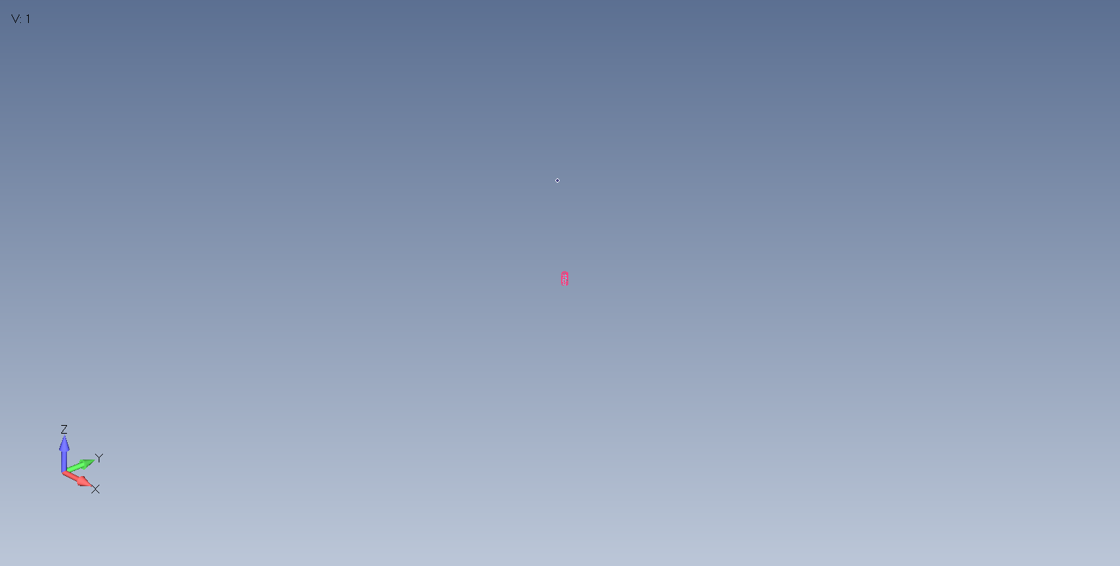

MV_BoreholeVolume_2_Volume_2_1 = ( S15, S17, S6 ) **(povrsine na delu drugog stuba u sloju 2)**

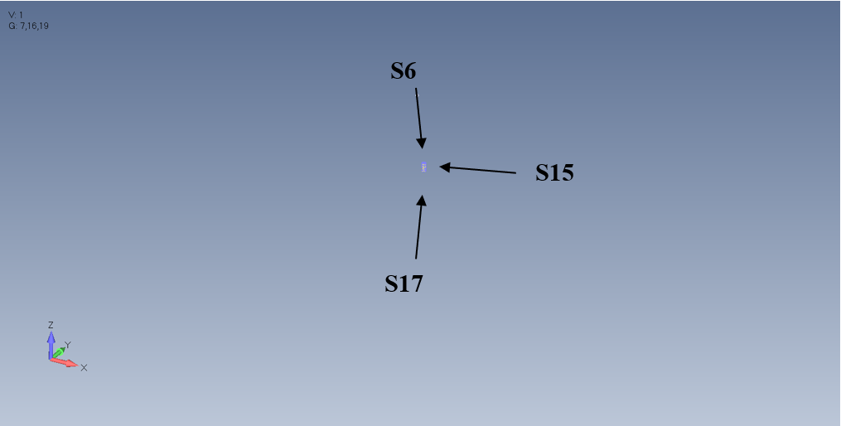

UV_BoreholeVolume_3_1 = ( V6 ) **(sloj 3)**

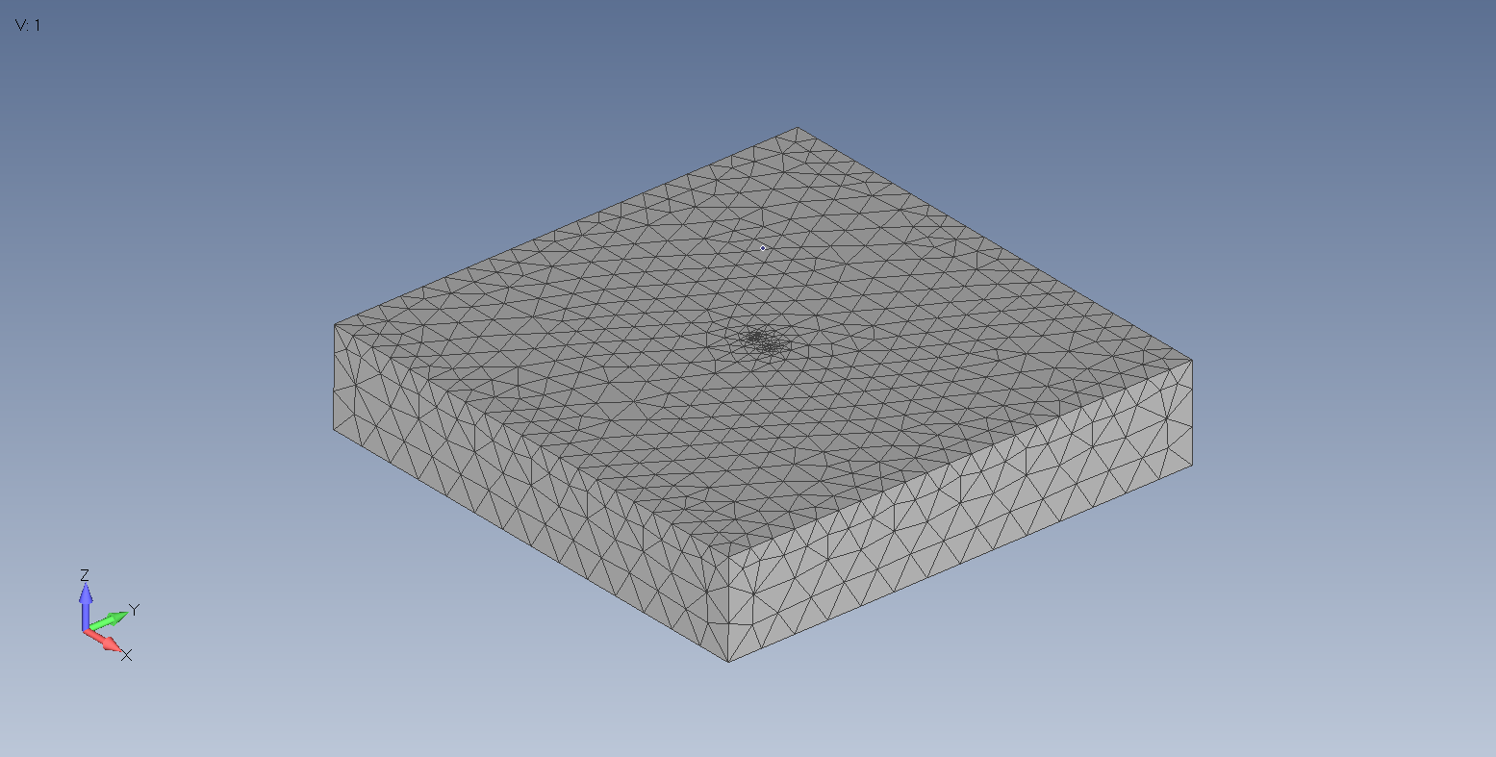

MV_BoreholeVolume_3_1 = ( S18, S19, S20, S21, S23, S24, S25, S26, S27, S9 ) (povrsine sloja 3)

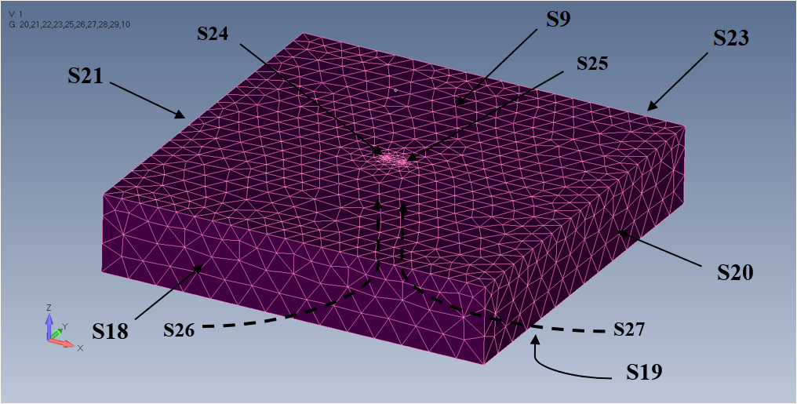

UV_BoreholeVolume_3_Volume_1_1 = ( V7 ) **(deo prvog stuba u sloju 3)**

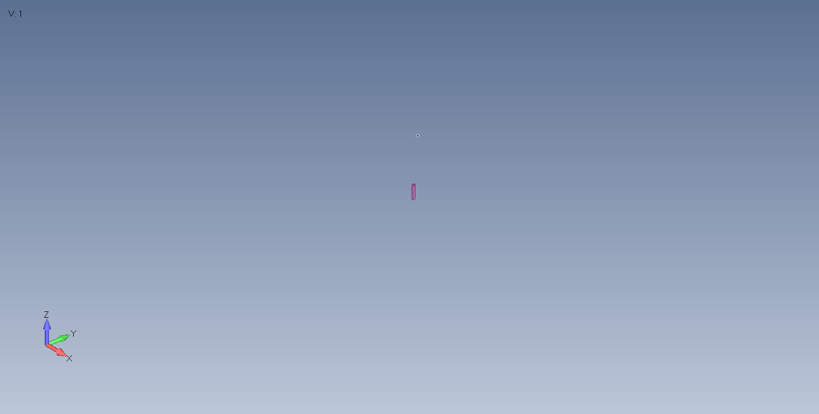

MV_BoreholeVolume_3_Volume_1_1 = ( S16, S24, S26 ) **(povrsine na delu prvog stuba u sloju 3)**

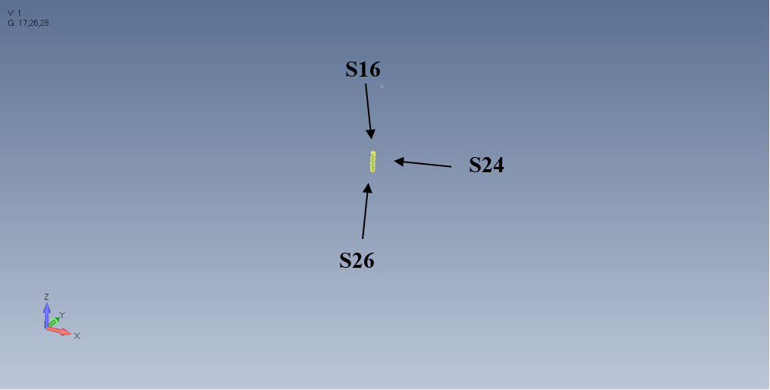

UV_BoreholeVolume_3_Volume_2_1 = ( V8 ) **(deo drugog stuba u sloju 3)**

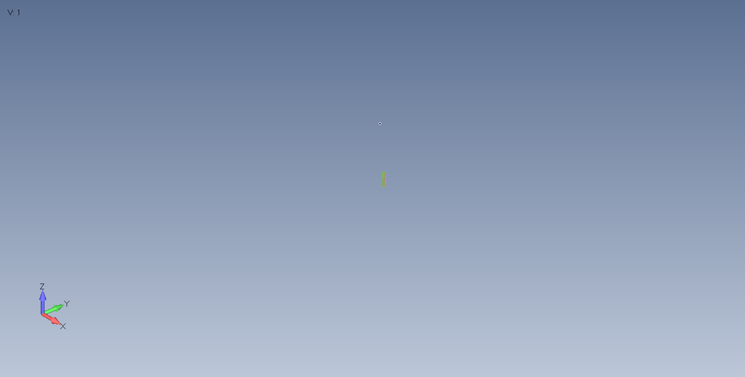

MV_BoreholeVolume_3_Volume_2_1 = ( S17, S25, S27 ) **(povrsine na delu drugog stuba u sloju 3)**

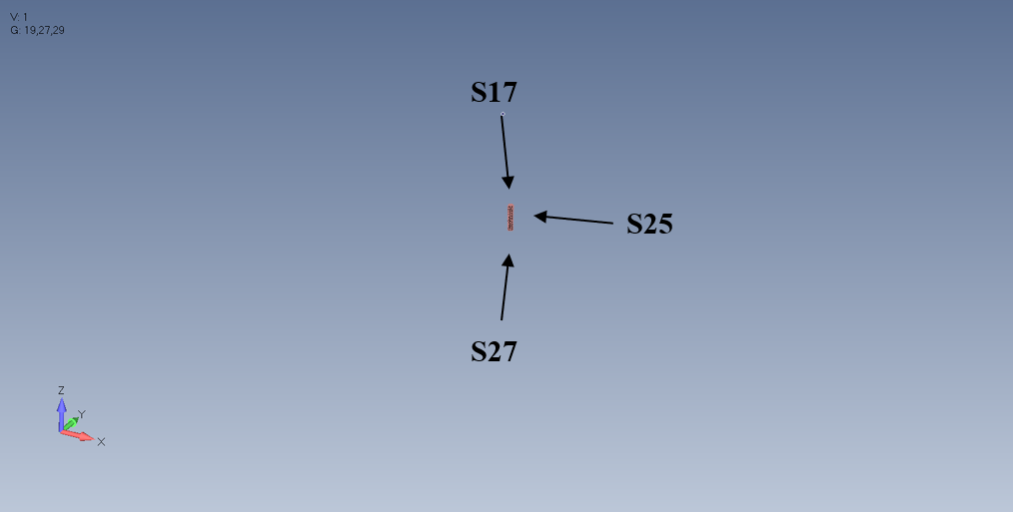

UV_BoreholeVolume_4_1 = ( V9 ) **(sloj 4)**

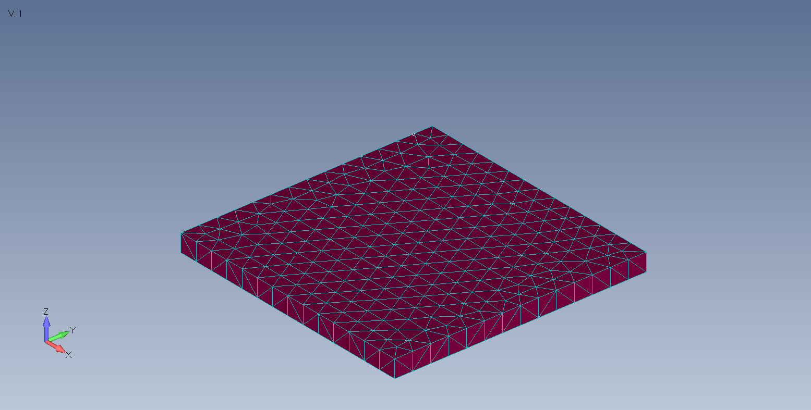

MV_BoreholeVolume_4_1 = ( S19, S28, S29, S30, S31, S32 ) **(povrsine u sloju 4)**

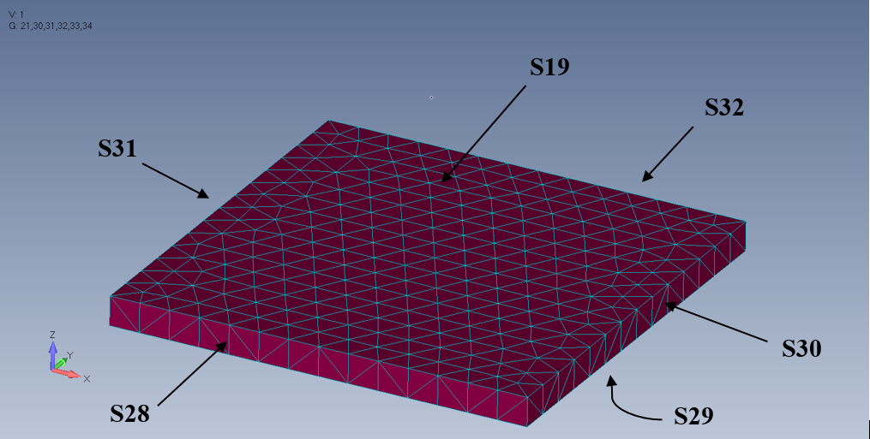

UV_Volume_1_1 = ( V10 ) **(deo prvog stuba van slojeva)**

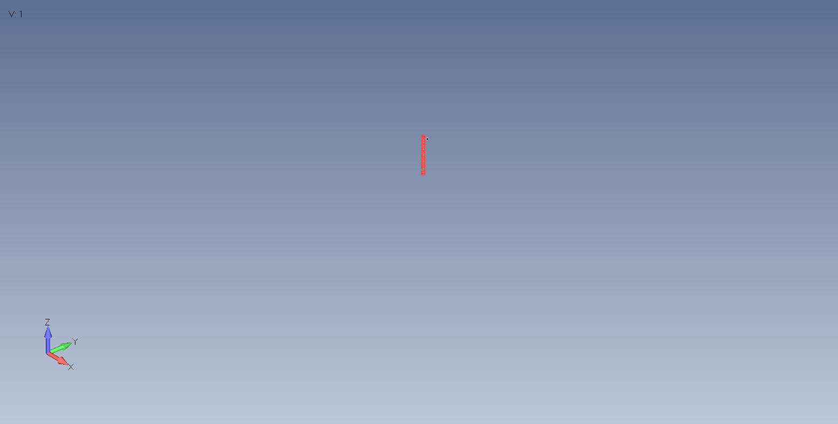

MV_Volume_1_1 = ( S34, S35, S5 ) **(povrsine na delu prvog stuba van slojeva)**

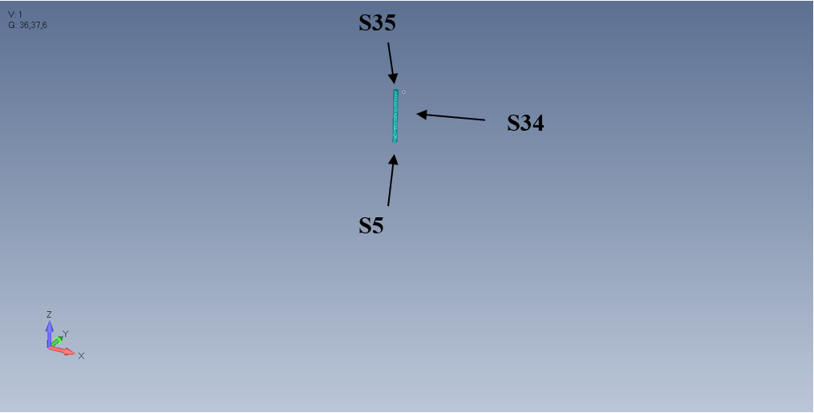

UV_Volume_2_1 = ( V11 ) **(deo drugog stuba van slojeva)**

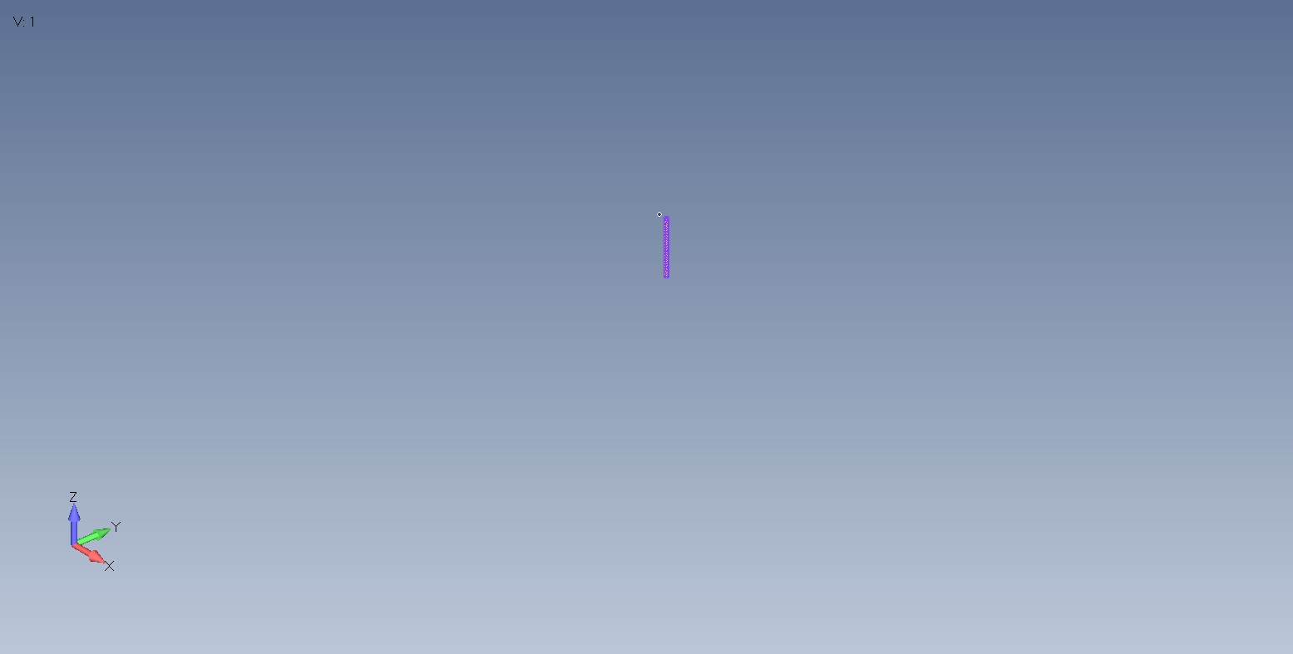

MV_Volume_2_1 = ( S36, S37, S7 ) **(povrsine na delu drugog stuba van slojeva)**

